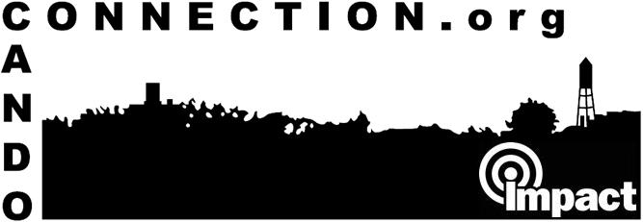
Impact-Cando Connection Fund
2701 12th Street South, #14
Fargo, ND 58103
(701) 234-1706 • cjeggl@gmail.com
www.candoconnection.org

2024 IMPACT-CANDO CONNECTION FUND CARING CAMPAIGN DONATION FORM

____ Enclosed is a donation in the amount of $_______for the 2024 Impact-Cando Connection Fund Caring Campaign.

Name: ___________________________________________________________________________
Business Name (if applicable) : _____________________________________________________________
Address: ____________________________________________________________________________
City/State/Zip: ________________________________________________________________________
Phone (Home): (____)__________________ Phone (Business-if applicable): ( )__________________
Phone (Cell): (____)_______________________ Email: _________________________________________

____ I/We wish this donation to be Anonymous.

My/Our donation is in honor of: ____________________________________________________________

My/Our donation is in memory of: __________________________________________________________

Please make your check payable to Impact-Cando Connection Fund and send it, along with this completed form to the address listed below. Thank you so much for your support of our 2024 Caring Campaign!

Attn: Cindy Eggl, Advisory Board Member
Impact-Cando Connection Fund
2701 12th Street South, #14
Fargo, ND 58103

Questions? Call: 701-234-1706 or Email: cjeggl@gmail.com

